**Intro To Microcontrollers Lab**

**Part 0: Introduction**

**General Overview:**

This will be a 5 part microcontroller, circuits, and coding lab. You will be: making a light blink, making a light fade, making a light fade based on your movement, making a buzzer sound at different tones, and making a buzzer sound at different tones based on your movement. Feel free to do as much or as little of the lab as you like. If you finish all 5 parts, you are welcome to create your own circuit with the help of your group mentor.

The code for all parts is written so that there is a brief description of what we would like you to do. We highly encourage that you try to fill in the code yourself. If you get stuck, or do not have any coding experience, feel free to see the solutions that are commented out in the code or ask your group mentor for help.

**Brief Overview of Parts:**

1) TI Launchpad MSP430 (we will refer to it as an MSP430)

This is a microcontroller, essentially a small computer on a chip, that will be powering our circuit and performing most of the functionality. The MSP looks like this: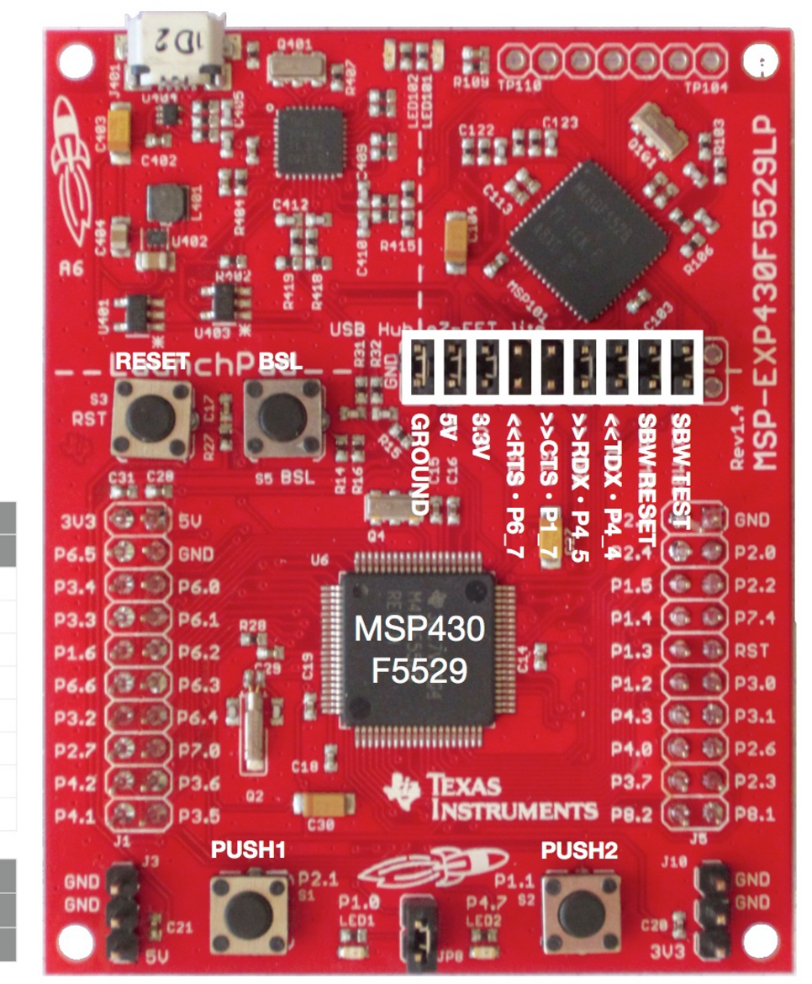

It has about 40 pins. When we refer to a pin during this lab we will call it “Pin PX.X of the MSP” where the ‘X’ will be filled in with numbers. Additionally, we will be plugging wires into the holes on the back of the board with the breadboard placed in the middle. The MSP will be connected to the computer through the given USB cord.

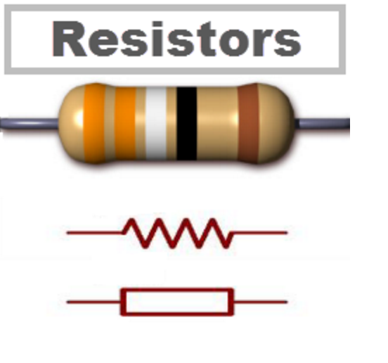

2) Resistors

A resistor “resists” or limits the current across it. These are electrical components that will be used in this lab for dividing voltages and limiting currents. They have resistance values which are noted as color bands on the physical resistor itself. The middle symbol on the right is a circuit schematic symbol for a resistor

5) Photoresistors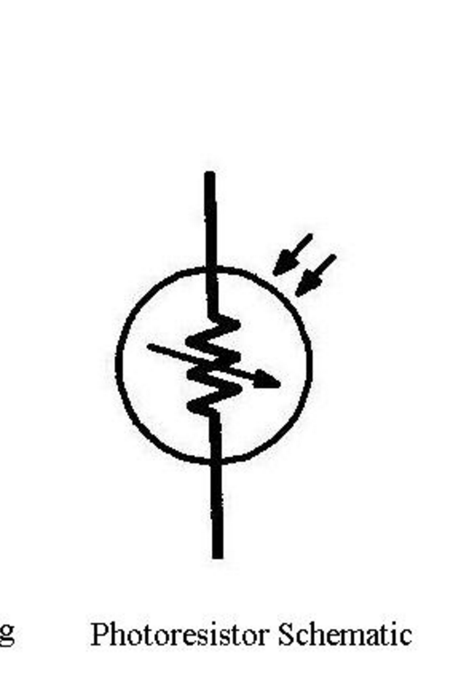

These are resistors that vary their resistance based on the amount of light they sense. The rightmost symbol is a circuit schematic symbol for a photoresistor.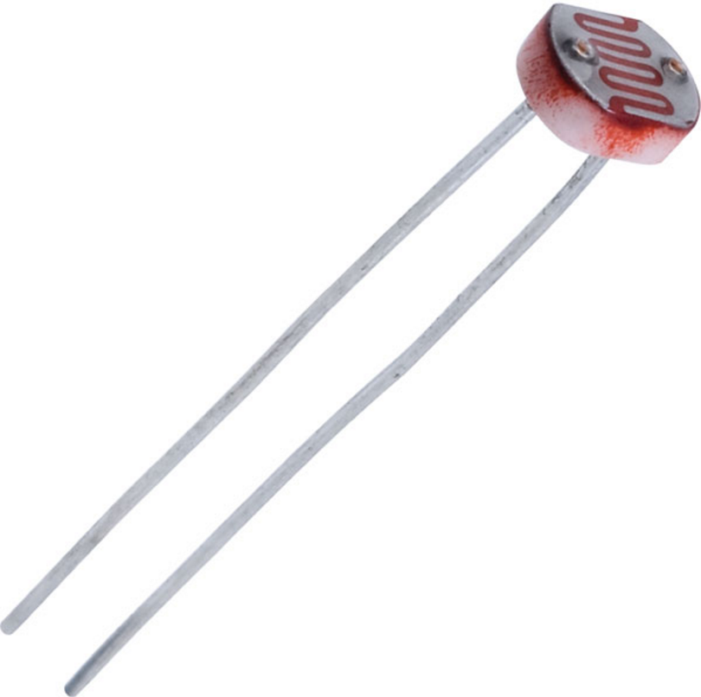

4) LEDs

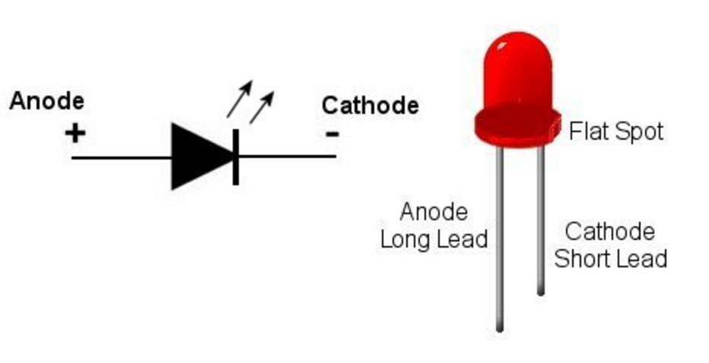

When current flows through an LED in the right direction, it generates light!

5) Piezo Buzzer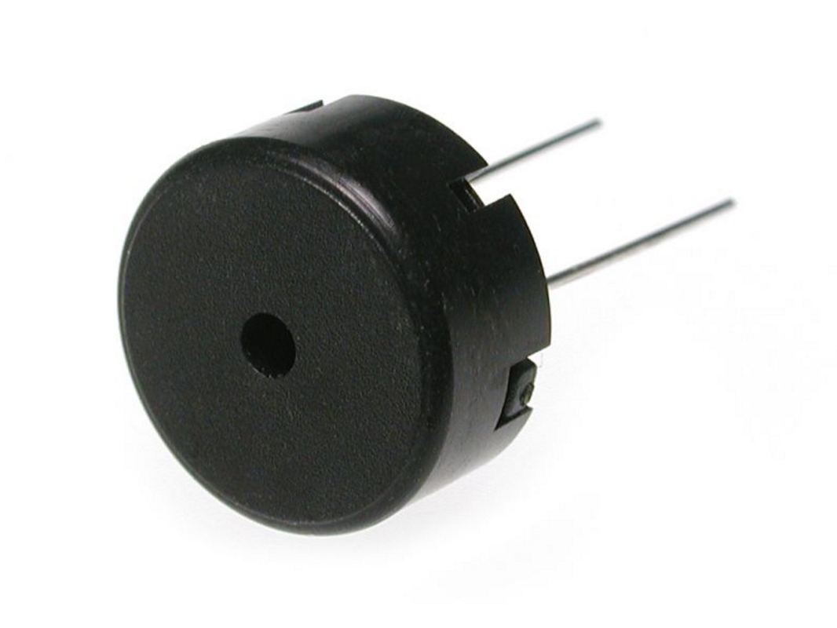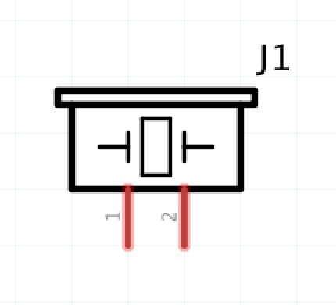

Piezo Buzzers are like speakers. They have a small piezo-electric element inside of them, which “Bends” when there is a voltage across it. This forms a basic speaker

6) Breadboards

Breadboards are what we build our circuit on. Internally, all the holes in a column of the breadboard. The breadboards are perfectly sized to fit in between the header of the MSP. **PLEASE DO NOT STICK YOUR BREADBOARD TO THE MSP.** We need to reuse the MSPs between lab sections.

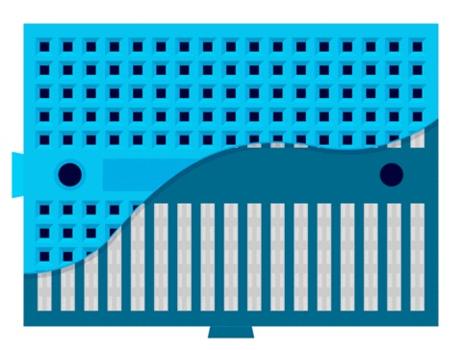

7) Oscilloscope

Oscilloscopes are what we use to measure the output voltage of our circuit. An oscilloscope probe is what we use to send the voltage of our circuit to the oscilloscope. An oscilloscope displays the voltage of your circuit where the oscilloscope probe is probing. The oscilloscope has ways to adjust the display, but for now, we’ll just have you hit the button labeled autoscale in the top right.

To use the oscilloscope, first connect your oscilloscope to the part of the circuit you want to measure, and connect the black alligator clip to the ground of the circuit, which is usually the blue rail on the breadboard.

**Part 1: LED Blinker**

**Materials:**

1. 1 TI Launchpad MSP430
2. 1 Green LED
3. 1 300 Ohm Resistor

**Description:**

We will first build a circuit that turns on an LED when the MSP430 is connected to it. Then we will write code to make the LED blink on and off.

**Circuit:**

1. Schematic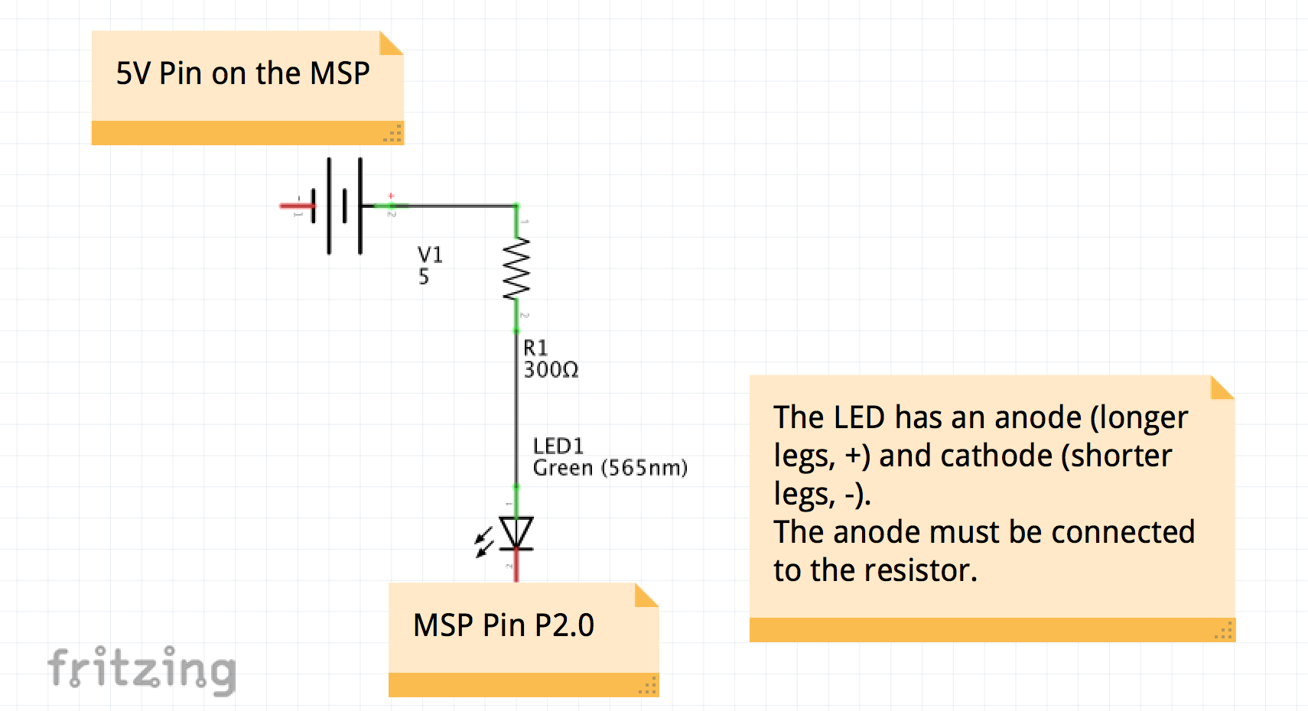
2. Breadboard 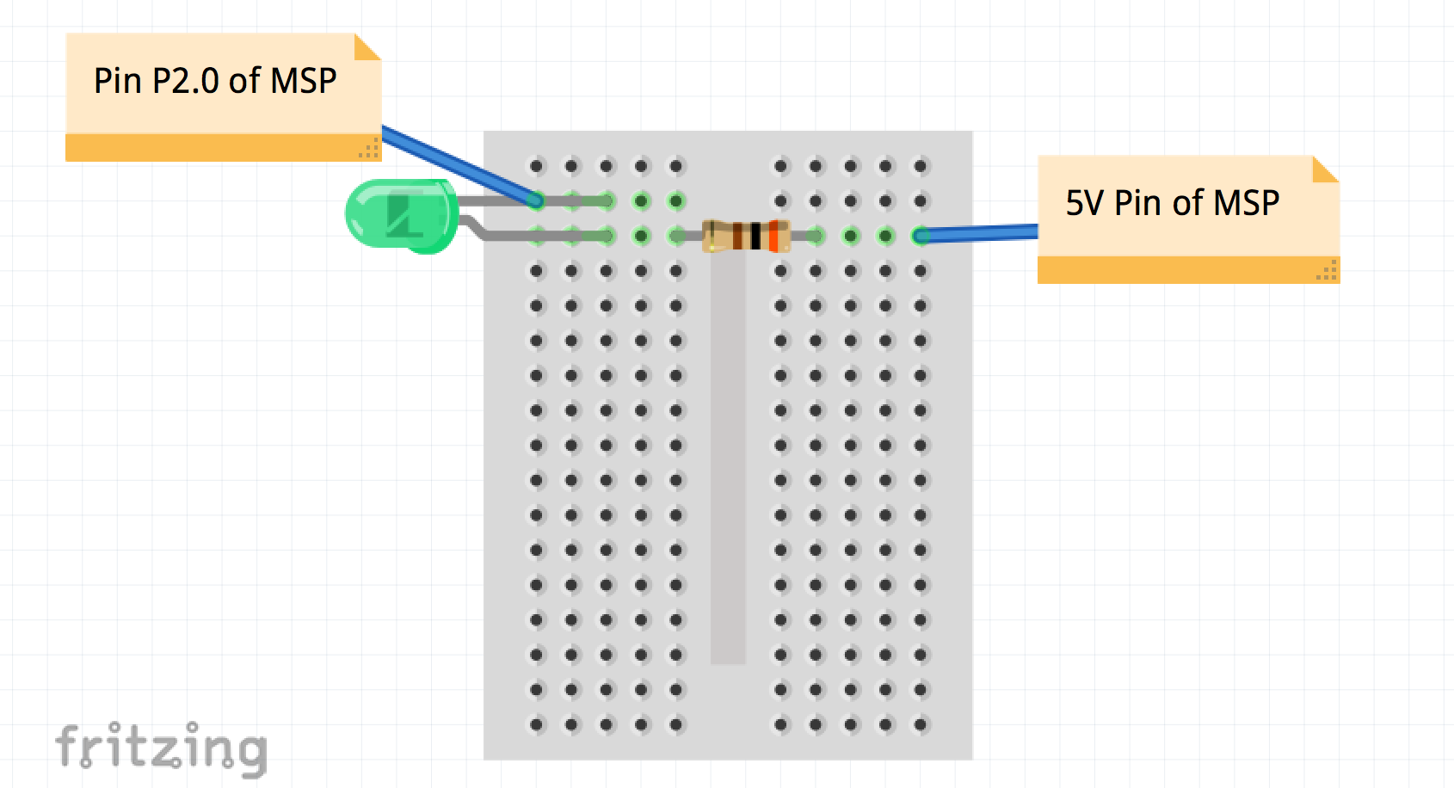

**Code:**

The unfilled code can be found in the microcontoller_lab1_skeleton folder. All instructions and descriptions are commented directly into the code. The solutions are in the microcontroller_lab1 folder.

**Part 2: LED Fader**

**Materials:**

1. 1 TI Launchpad MSP430
2. 1 Green LED
3. 1 300 Ohm Resistor

**Description:**

Now let’s make the LED fade. We’re going to change the brightness of the LED through something known as PWM. Basically, we turn the LED on for a short amount of time, and turn it off for a short amount of time. Do this fast enough, and persistence of vision makes humans think the LED is continuously on. As you increase the ratio of on time to off time, the LED gets brighter.

**Circuit:**

Same as in part 1.

**Code:**

The unfilled code can be found in the microcontroller_lab2_skeleton folder. All instructions and descriptions are commented directly into the code. The solutions are in the microcontroller_lab2 folder.

**Part 3: Photoresistor Output Graph**

**Materials:**

* 1 TI Launchpad MSP430
* 1 Photoresistor
* 1 5.1 kOhm Resistor
* 1 Wire

**Description:**

We will be graphing the voltage across a resistor on the computer and see how the photoresistor changes resistance and voltage as you cover it up.

**Circuit:**

1. Schematic 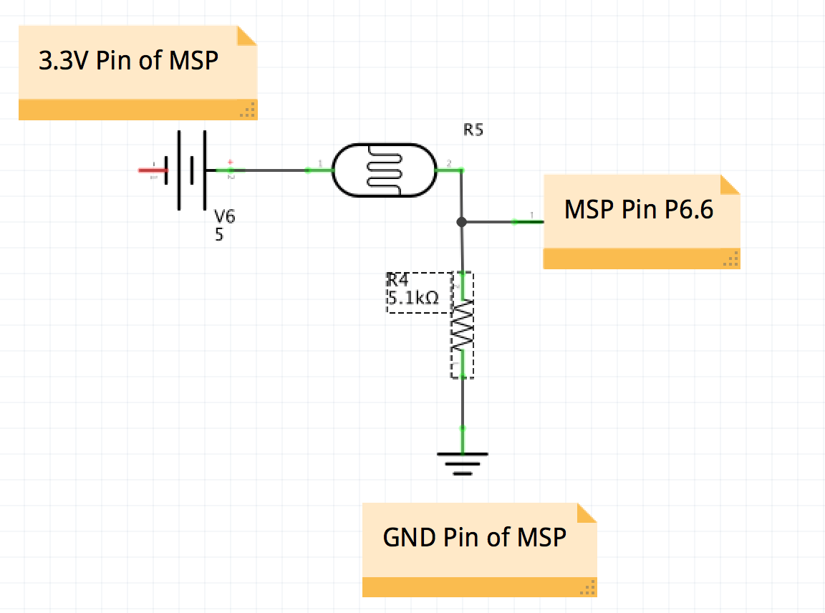
2. Breadboard 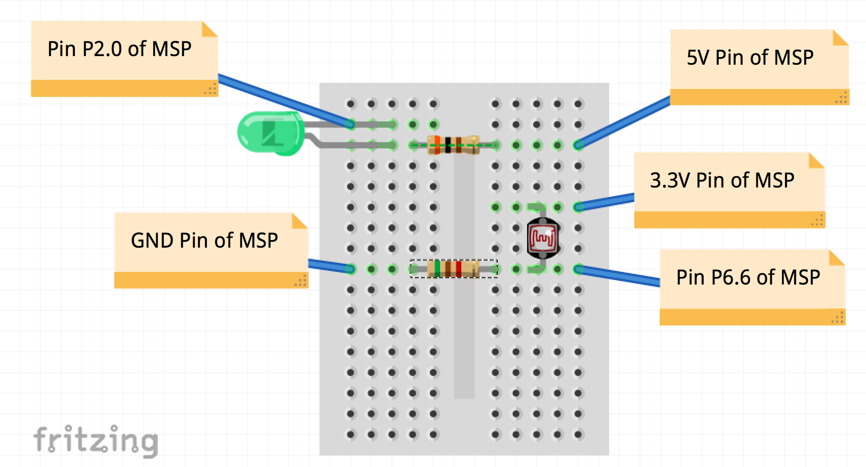

**Code:**

The unfilled code can be found in the microcontroller_lab3_skeleton folder. All instructions and descriptions are commented directly into the code. The solutions are in the micrcontroller_lab3 folder. For this part of the lab after the code is uploaded, you should open Serial Monitor using the magnifying glass button in the upper right hand corner of Energia. Set the baud rate in the lower right hand corner to 56700.

**Part 4: Buzzer Tone Shifter**

**Materials:**

1. 1 TI Launchpad MSP430
2. 1 Photoresistor
3. 1 Wire

**Description:**

We will build a circuit that outputs a changing tone. In order to produce a tone, we send a square wave to the buzzer. As the frequency of the wave changes, the frequency of sound the buzzer outputs changes.

**Circuit:**

1. Schematic 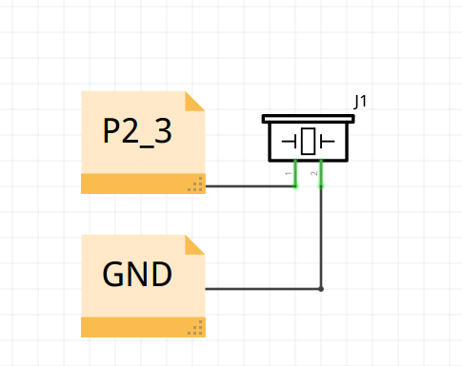
2. Breadboard 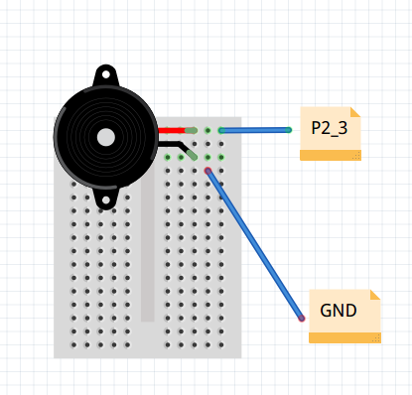

**Code:**

The unfilled code can be found in the microcontroller_lab4_skeleton folder. All instructions and descriptions are commented directly into the code. The solutions are in the microcontroller_lab4 folder.

**Part 5: Buzzer Tone Shifter w/ Input**

**Materials:**

1. 1 TI Launchpad MSP430
2. 1 Photoresistor
3. 1 5.1 kOhm Resistor
4. 1 Wire

**Description:**

Here we will build a circuit that measures the light coming in. Based on the input light, it outputs a tone. This is a basic “Music Player”.

**Circuit**

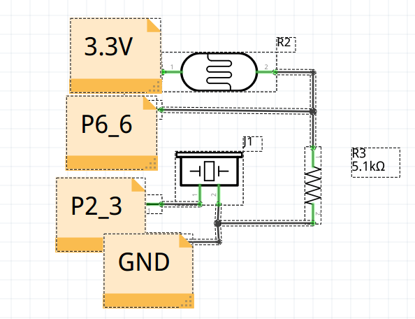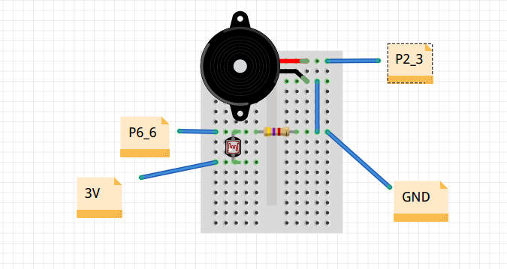

**Code:**

The unfilled code can be found in the eecs_day_lab5_skeleton folder. All instructions and descriptions are commented directly into the code. The solutions are in the eecs_day_lab5 folder.

**Part 5 Extension: Adding a Fading LED**

As a challenge try to make both the LED fade and the buzzer change pitch as you move your hand above the photoresistor.

**Part 6: Playing Twinkle Twinkle**

**Materials:**

* Same circuit as Part 4 or 5

**Description**

We’ll try to make our circuit play twinkle twinkle little star. We’ve already provided frequencies for various notes for you in the code. See if you can make the MSP play Twinkle Twinkle.

**Part 7 Making a 3-bit Digital to Analog Converter**

**Materials:**

1. 1 TI Launchpad MSP430
2. 10 2.2k resistors
3. 4 male-male wires
4. Some Wires
5. 1 Oscilloscope
6. 1 Oscilloscope probe

In this lab we’re going to build a digital to analog converter. Digital analog converters are ways to convert digital data into analog data that is understandable to humans. Computers use data that is written in **binary**, which basically means that it will look like a bunch of 0’s and 1’s. For those of you more interested, binary means that numbers are in base 2 instead of base 10. Here is a link for more on binary numbers.

<http://www.math.grin.edu/~rebelsky/Courses/152/97F/Readings/student-binary>.

We will be building a **resistor ladder** for our digital to analog converter. 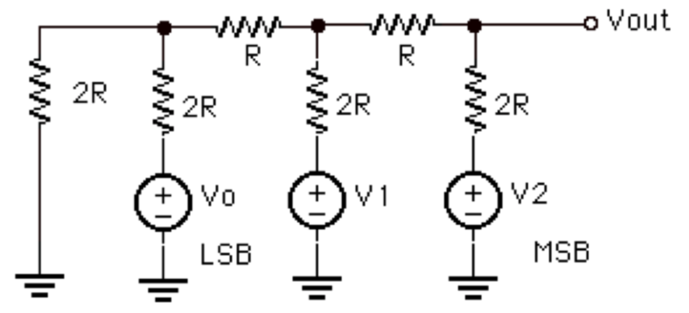

V0, V1, and V2 represent the 0’s and 1’s sent from the computer. The number 1 represents “on” and the number 0 represents “off.” For example, if the digital data is 101, this means that V0 is on, V1, is off, and V2 is on. This resistor ladder converts digital data to analog data.

Connect the blue rail on the breadboard to the pin labelled GND on the Launchpad. Then, connect V0, V1, and V2 to pins 8, 9, and 10 respectively on the Launchpad.

When you’re done building the circuit, find the code labeled dac.ino and open it in energia. Make sure you’re on the right port and then upload the code.

Turn on the oscilloscope, connect the probe to Vout and the black alligator clip to the blue rail, or ground. Then hit the autoscale button the oscilloscope probe. You should see this. What’s happening is the code in dac.ino is going through binary data and the digital to analog converter is converting each piece of data. The digital data goes through 0, 1, 10, 11, 100, 101, 110, and 111. The converter converts these, in order, to 0, 1, 2, 3, 4, 5, 6, and 7

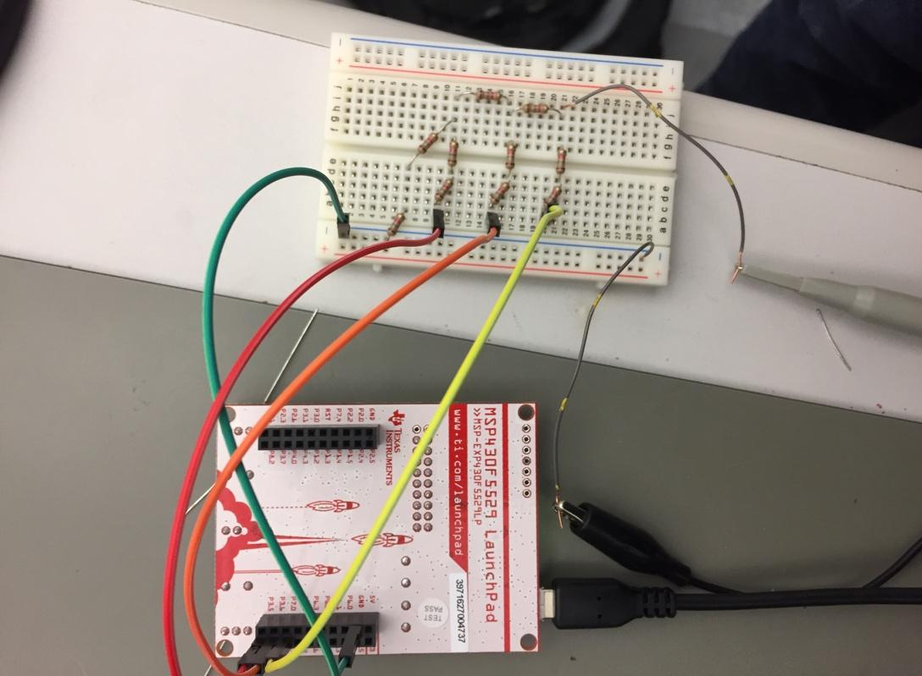

Your circuit should look a little like this, and the oscilloscope output should look like what’s shown below.